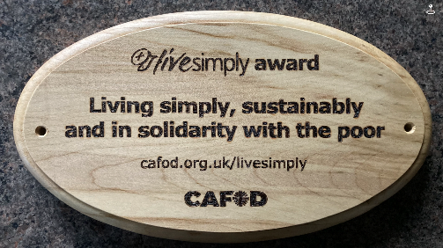
How can we Live Simply?
Live Sustainably
Reduce the amount of single use plastic in your lunchbox.
Wear an extra jumper rather than turning up the heating
Repair or upcycle something rather than throwing it away
Turn off the lights when leaving a room
Turn off the computer or Xbox when not in use
Turn off the tap when brushing your teeth
Use a refillable water bottle
Try and have 2 days not eating meat
Walk or cycle to school
Grow your own fruit/veg
Re wild part of your garden
Recycle all you can
Share a meal using locally sourced produce or sea


Live In Solidarity
Find out about a country suffering because of climate change eg Bangladesh/Haiti
Donate to your local food bank
Use Fairtrade produce when possible
Donate some of your belongings to a charity shop
Visit the CAFOD website and find out about causes you can support
Read the lyrics and listen to Harvest for the World by the Isley brothers and reflect on the words.



Live Simply
Spend 5 minutes a day thanking God for creation
Go for a walk in nature and capture an image of God’s creation
Find out about St Therese of Lisieux and her ‘Little Way’
Put out water and food for wildlife
Say a prayer for our common home each night
Read a favourite passage from the Bible
Turn of the TV and read a book or play a game together.
Go outside and listen to the birds singing as a reminder of the beauty of creation
Plant some bulbs or wild flowers to care for.
Go outdoors and use your senses- What do you hear, see, smell, feel, taste?


