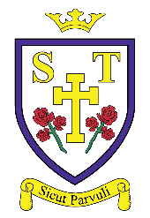
The information below gives an overview of the second ‘branch’ being taught during Autumn 2– Prophecy and Promise. You may wish to talk to your child about their understanding of the topics covered and share the ‘Learning at Home’ activities with them.
Years 5 and 6
Children will reflect on the prophets Elijah and John the Baptist as examples. For example, they will show some understanding of the cultural and religious context of Elijah’s time and why people needed to be reminded of God’s covenant. They will make links with the words of Isaiah, the preaching of John the Baptist, and the season of Advent. Children will know that the feast of Christ the King marks the end of the Church’s year and describe what is celebrated, making links with the ancestry of Jesus and the Jesse tree.
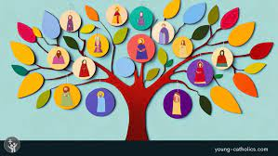
Learning at Home – How can you support your child at home?
- Discuss with the children how your family welcomes visitors to your home.
- Find out about some Christian symbols for Advent E.g. Advent wreath, calendar, Jesse tree. Use the CAFOD or Missio websites to get a religious Advent calendar.
- Discuss with your child how we prepare for the coming of Jesus. Find out about some Christian symbols for Advent e.g. advent wreath, calendar, Jesse tree.
- Challenge your child to reflect on the true meaning of Christmas through their actions. You could visit the CAFOD or Mission Together website to get a religious Advent calendar and complete their daily task to help you prepare for the coming of Christ.

Ask your child to think about how they can live out Catholic Social Teaching principles to make the world a better place.

Years 3 and 4
Children learn about the first part of the Mass. They will recognise and name some of the objects in a church and will understand why Catholics go to Mass. They will learn the different rules people have when they take part in Mass as well as the structure of Mass, naming the different parts of the Liturgy of the Word. Children will then learn about Advent and the signs and symbols that help Catholics live out this special season. They will learn about the Annunciation to Joseph and explore the meaning of the story.
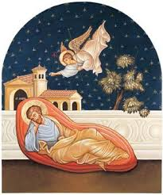
Years 1 and 2
In Years 1 and 2, children will understand that the Bible is a special book and encounter the stories and accounts of how people came to know God and the Good News of Jesus in the gospels. Children will sequence the accounts from the Annunciation through to the visit of the shepherds and know that in the Annunciation, God called Mary and she said ‘Yes’ to his call. Children will recognise that, for Christians, the Christmas story reveals God’s love by sending Jesus his Son.
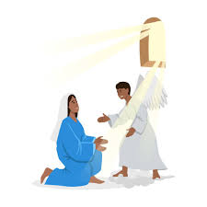
EYFS
In EYFS, children will know that Mary was chosen by God to be Jesus’ mother. They will learn that Mary and Joseph travelled to Bethlehem and that Jesus was born in a stable and laid in a manger. Children will know that the shepherds visited Jesus at the stable and that Advent is a time to get ready for Christmas. Finally, children will know that Jesus came for the whole world.


